Wedge Wire Elements: Wedge Wire Screens

Wedge Wire Screens

To complement our range of self cleaners and basket filters, we can now supply slot tubes, cylinders, and specialist design wedge wire products, including Wedge Wire Screens. Wire profiles from 0.75 mm to 2.2 mm wide are available. Alloys available include; Uranus 52N, 45N, Monel 400, 316Ti, 316L, 304. Various end pieces, in either stainless or plastic can be provided.

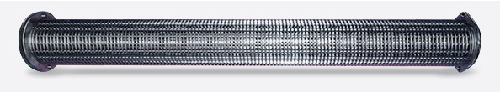

Tolerances on the slots, diameter & conical shape:  Diameter < 110mm  80% of the slots: +/-0,010mm  15% with a deviation of the nominal slot of max. +/-0,015  5% with a deviation of the nominal slot of max. +/- 0,030  Diameter > 110mm  80% of the slots +/-0,020mm  15% with a deviation of the nominal slot of max. +/-0,030  5% with a deviation of the nominal slot of max. +/-0,050  Diameter > 268mm  80% of the slots: +/-0,050mm  20% with a deviation of the nominal slot of max. +/-0,1mm  5% with a deviation of the nominal slot of max. +/-0,050 | Special tolerances available on request  Slot widths are from 10 micron, and with a recently developed wire profile, reliable accuracy of the slots is now possible.

Length of the Slot tubes  From Ø23 to Ø30 Max. length 1300mm  From Ø31 to Ø44 Max. length 2100mm  From Ø45 to Ø109 Max. length 2750mm  From Ø110 to Ø305 Max. length 3700mm  Special lengths on request | Tolerances on the diameter  From Ø20 to Ø100 Standard +/- 0,3mm  From Ø101 to Ø164 Standard +/- 0,5mm  From Ø165 to Ø268 Standard +/- 1mm  From Ø269 to Ø305 Standard +/- 2mm  Special tolerances on request

Flow directions can be in to out, or out to in, burst and collapse pressures are available if required. The slots are spirally wound, and can be varied along the length.

Below is an example of a custom designed screen and brush cleaning assembly used in the nuclear marine industry.
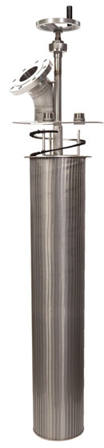

Conical slot tubes, 57 to 137 diameter
- Designed specifically to allow higher flow rates in a number of various configurations.
- Higher surface areas by using filters inside filters, allowing more compact systems.
- Retrofitting into longer housings, allows the total length to be utilised, as the conical design has the effect of creating an even pressure along the length of the tube.
- If used in a backwash system, the even pressure allows better solids removal along the total length.
- A full combination of conicals and cylindrical slot tubes, and flow directions is available.
- Oxford Filtration can assist in designing a system to accommodate specific needs, including oval shaped slot tubes.

Continuous cylinders; from 24 mm diameter up to 260 mm diameter:
- These cylinders have excellent roundness, the support bars are wrapped around the outside, allowing uninterrupted flow along the longitudinal slots.
- We have a large range of slot widths and diameters, if you have a specific requirement, individual toolings can be manufactured.
- Current range is from 10 micron, to 4 mm slot opening.
Quantities from 1 to 1,000+ can be supplied, our policy is to supply quality products at cost effective prices. Delivery times are dependant on if the products are from our standard or more specialist range.
Custom products can be designed and supplied, and due to recent investment in manufacturing, our range is continually under review for different requirements.

